**Name:** V Venkata Sri Prasad

**Batch:** Data Engineering

**Date:** 22/01/2024 – (Day 4)

**Topic:**

1. DML , DDL commands
2. Filtering Data

**Storing Data in a Table**

**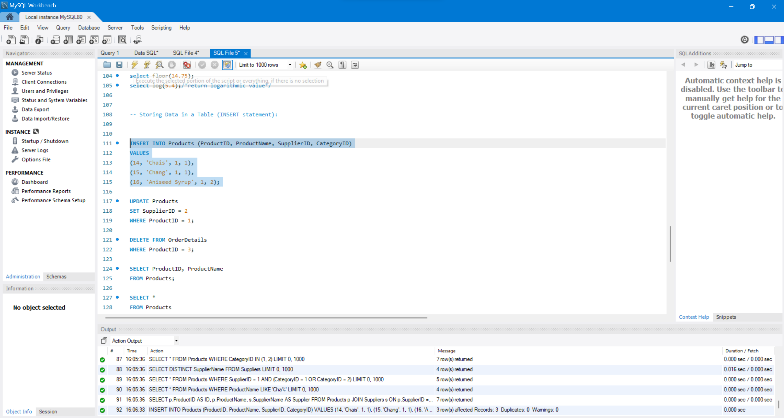  
Updating Data in a Table**

**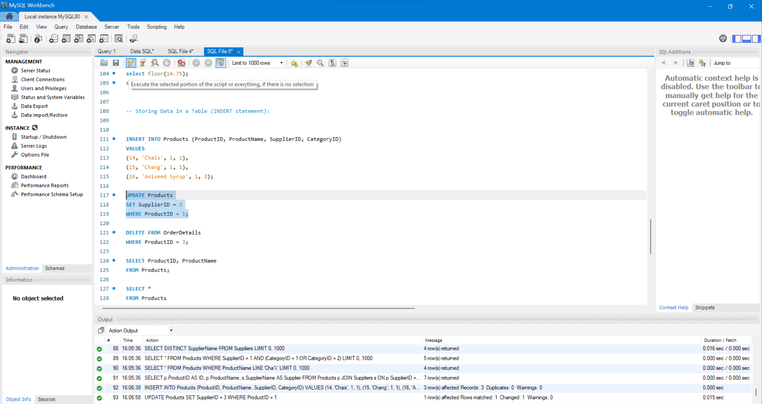  
Deleting Data from a Table**

**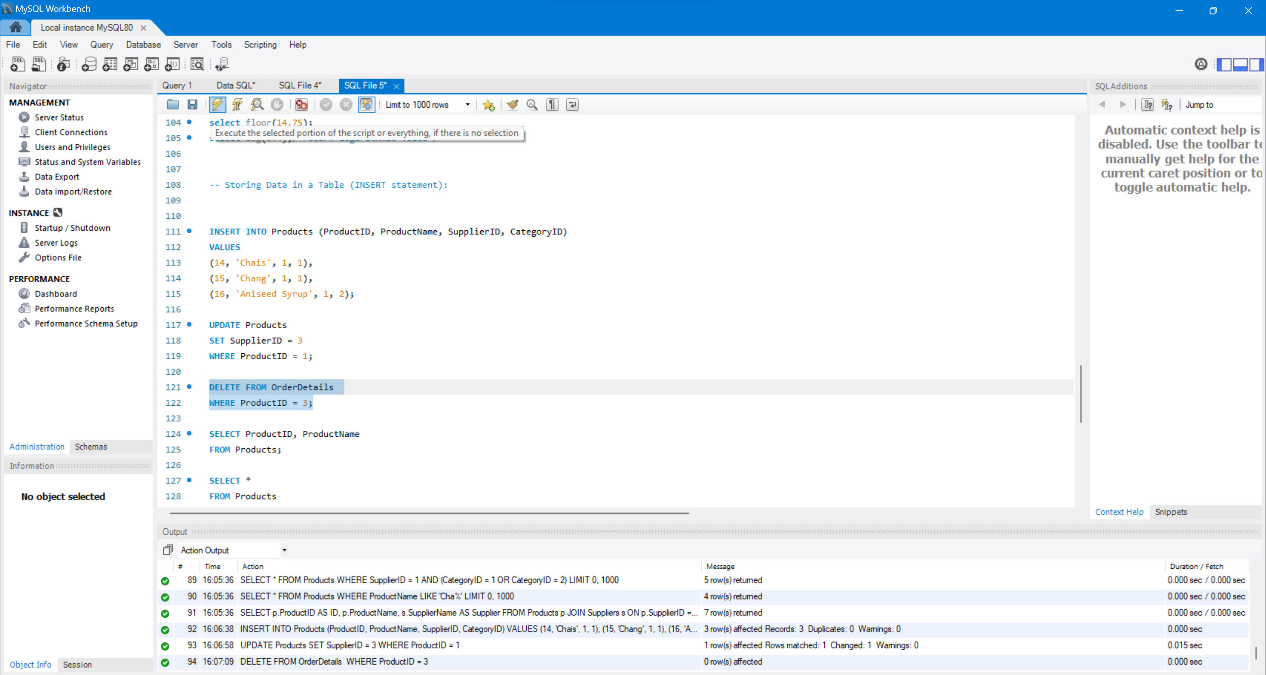  
Retrieving Specific Attributes**

**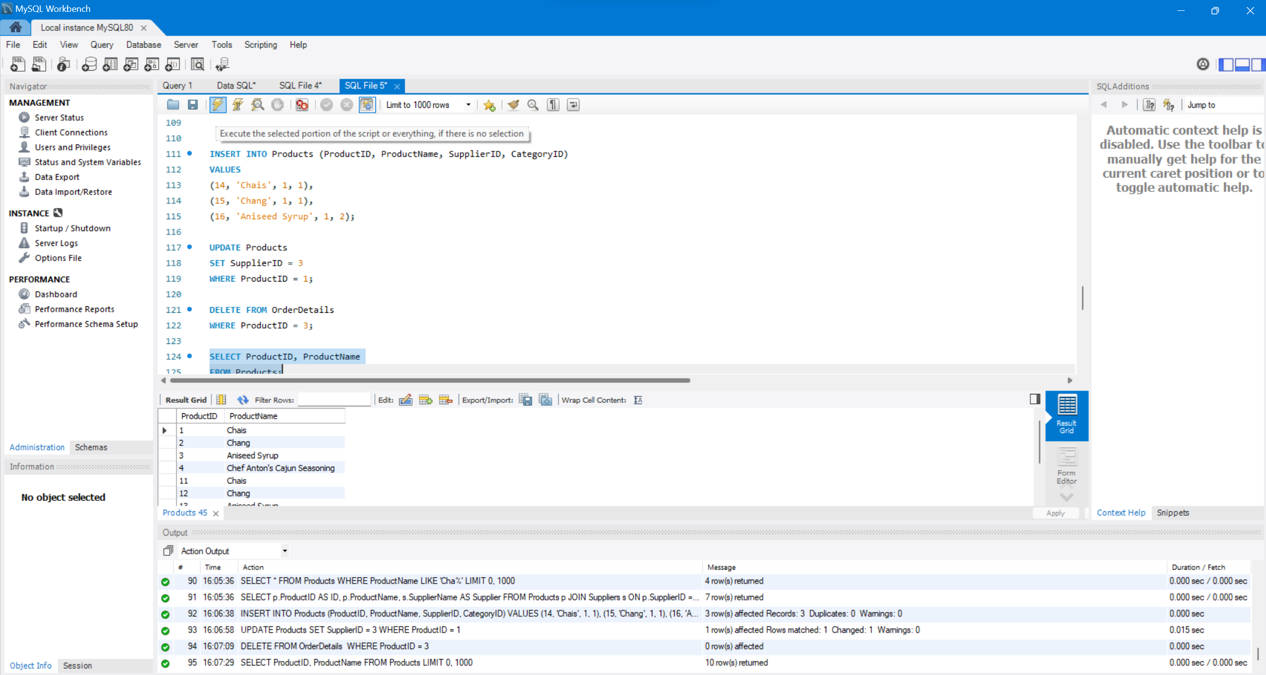  
Retrieving Selected Rows**

**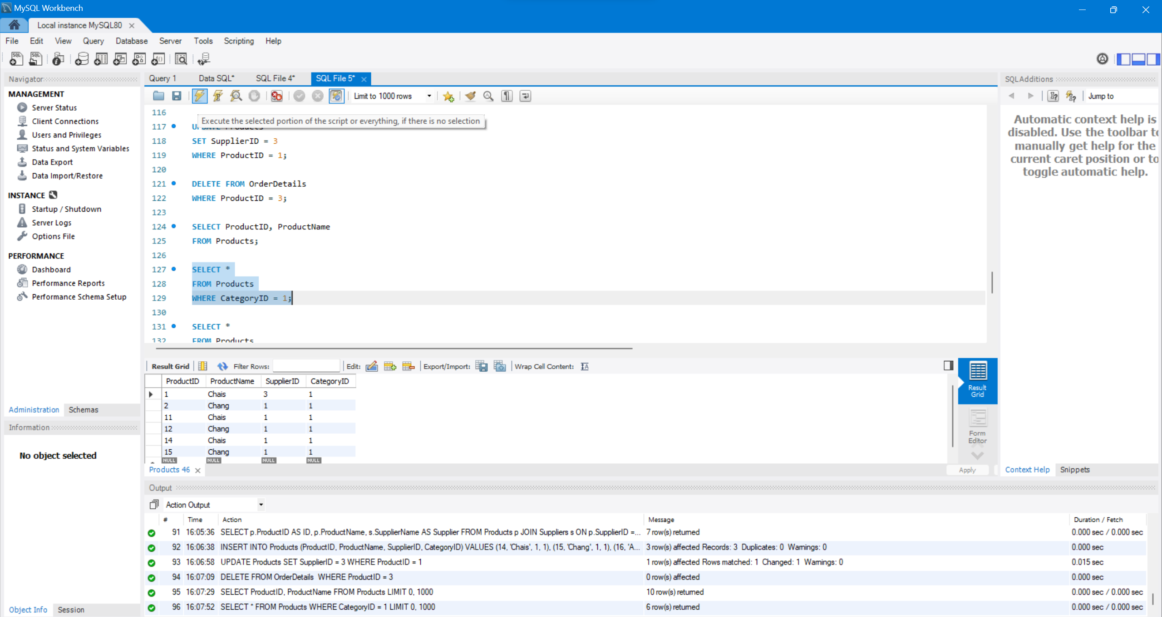  
Filtering Data: WHERE Clauses**

**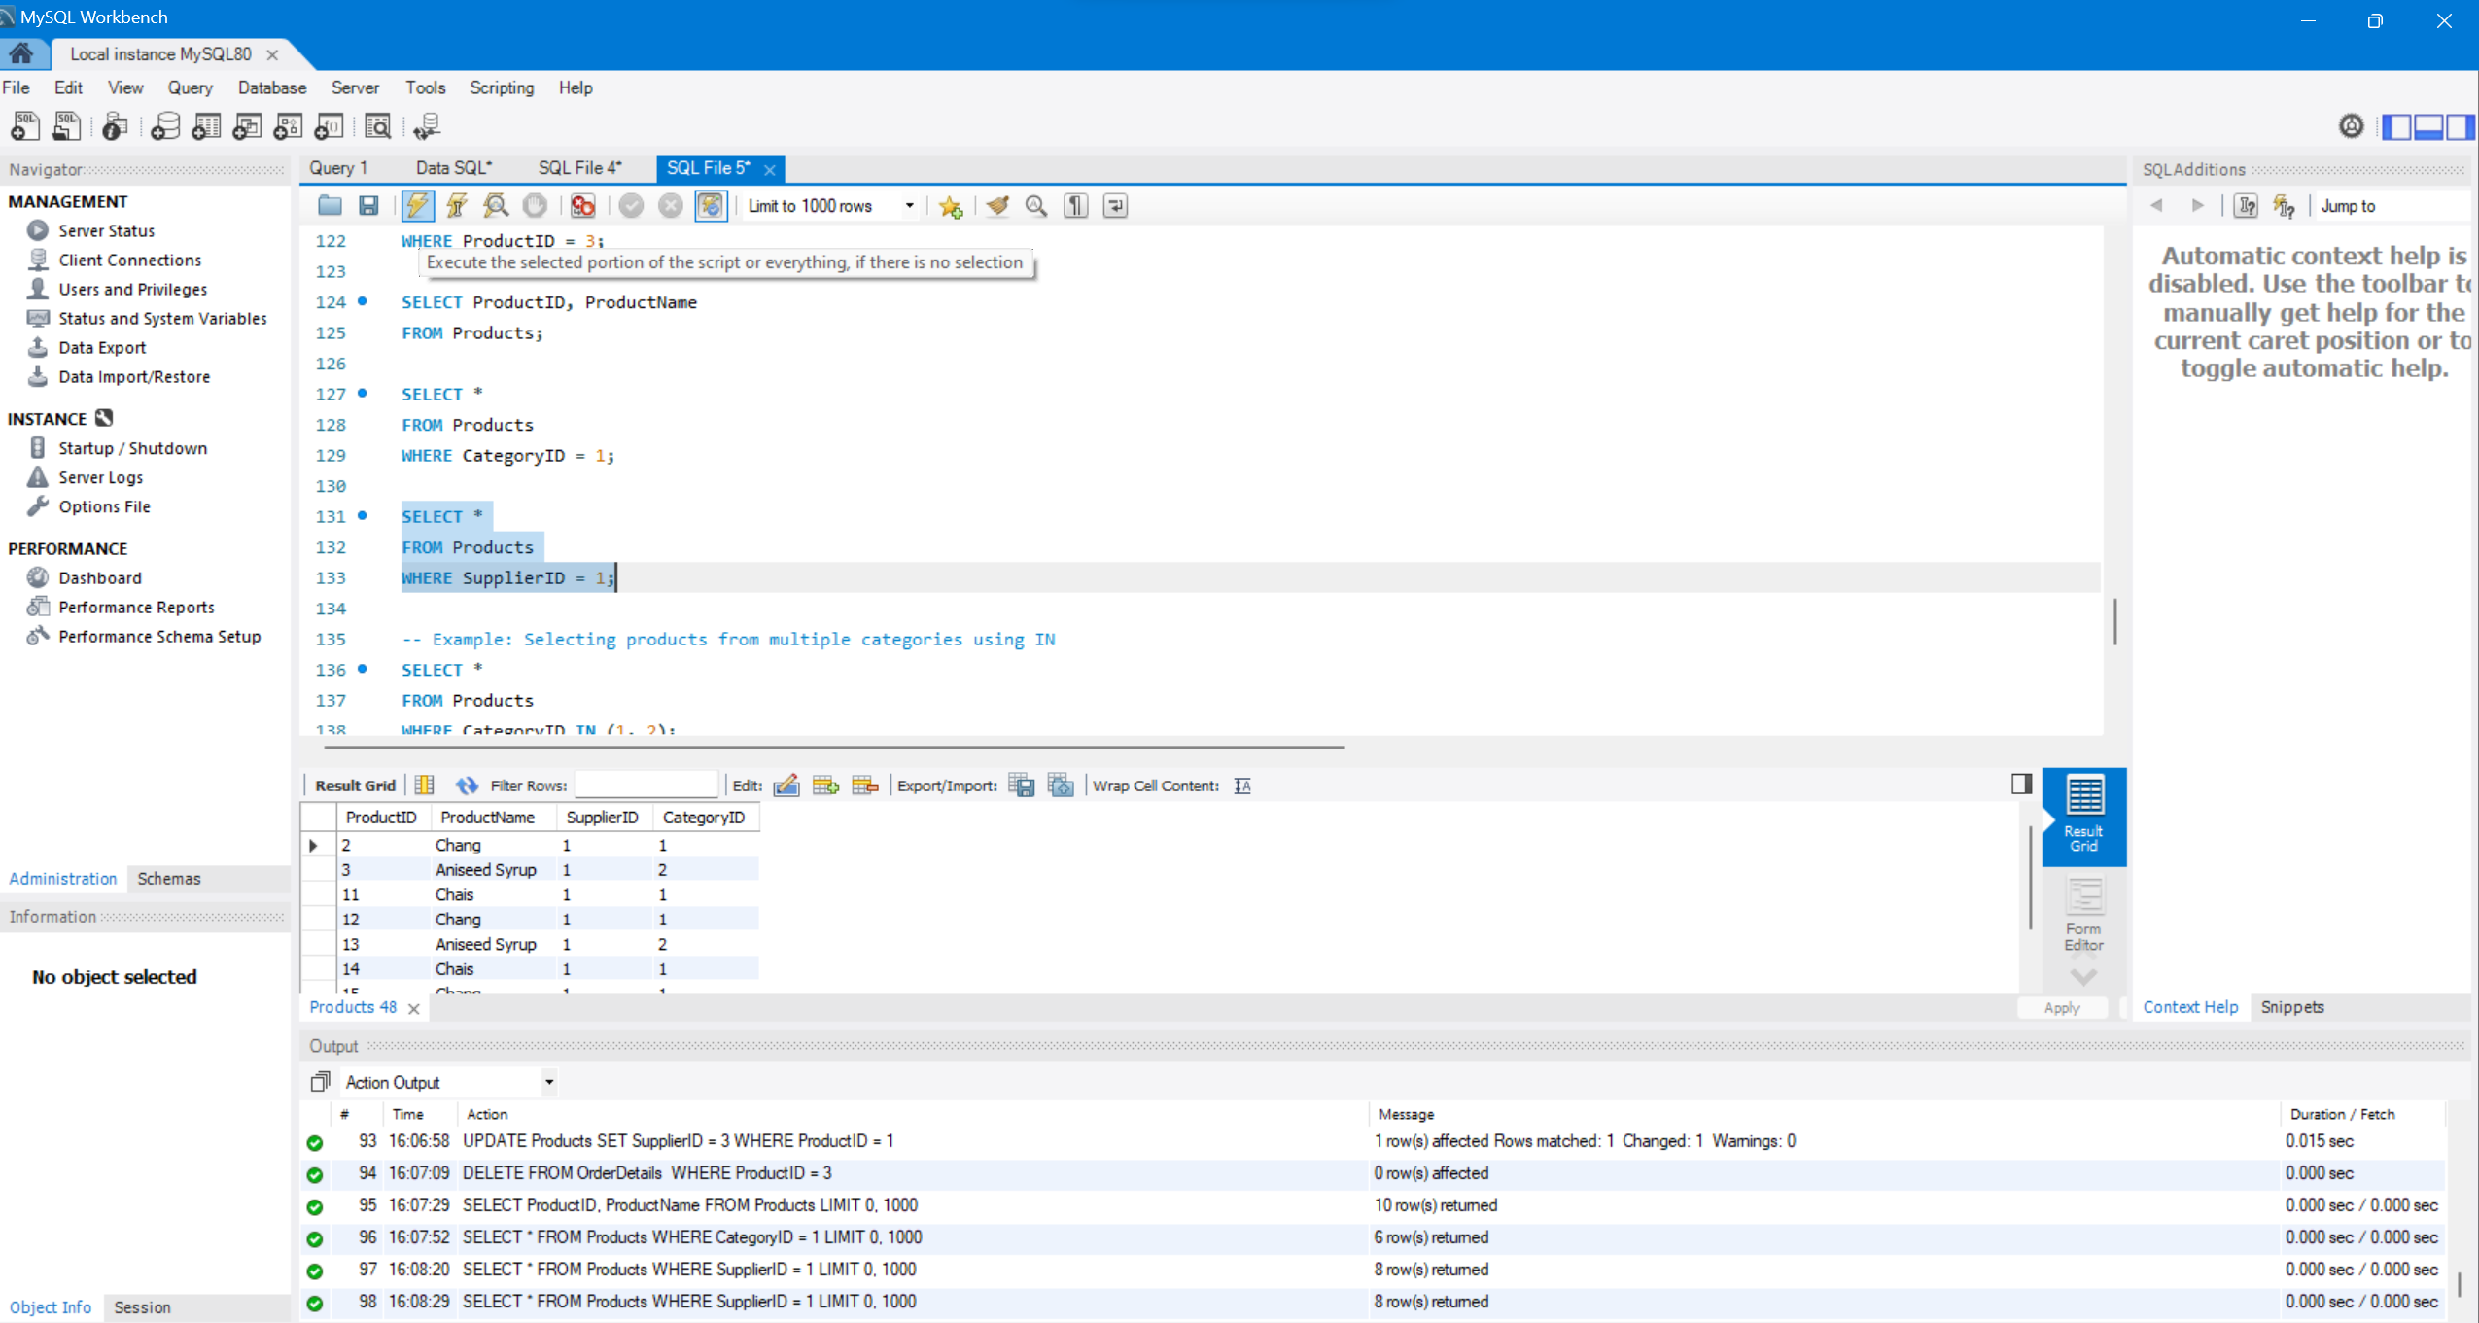  
Filtering Data: IN,DISTINCT,AND,OR,IN,BETWEEN,LIKE,Column & table aliases**

**IN**

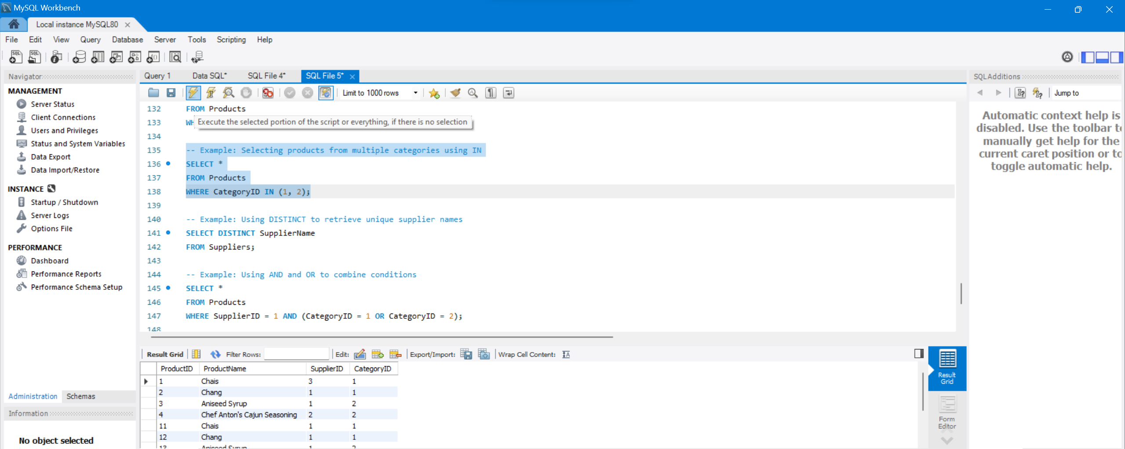

**DISTINCT**

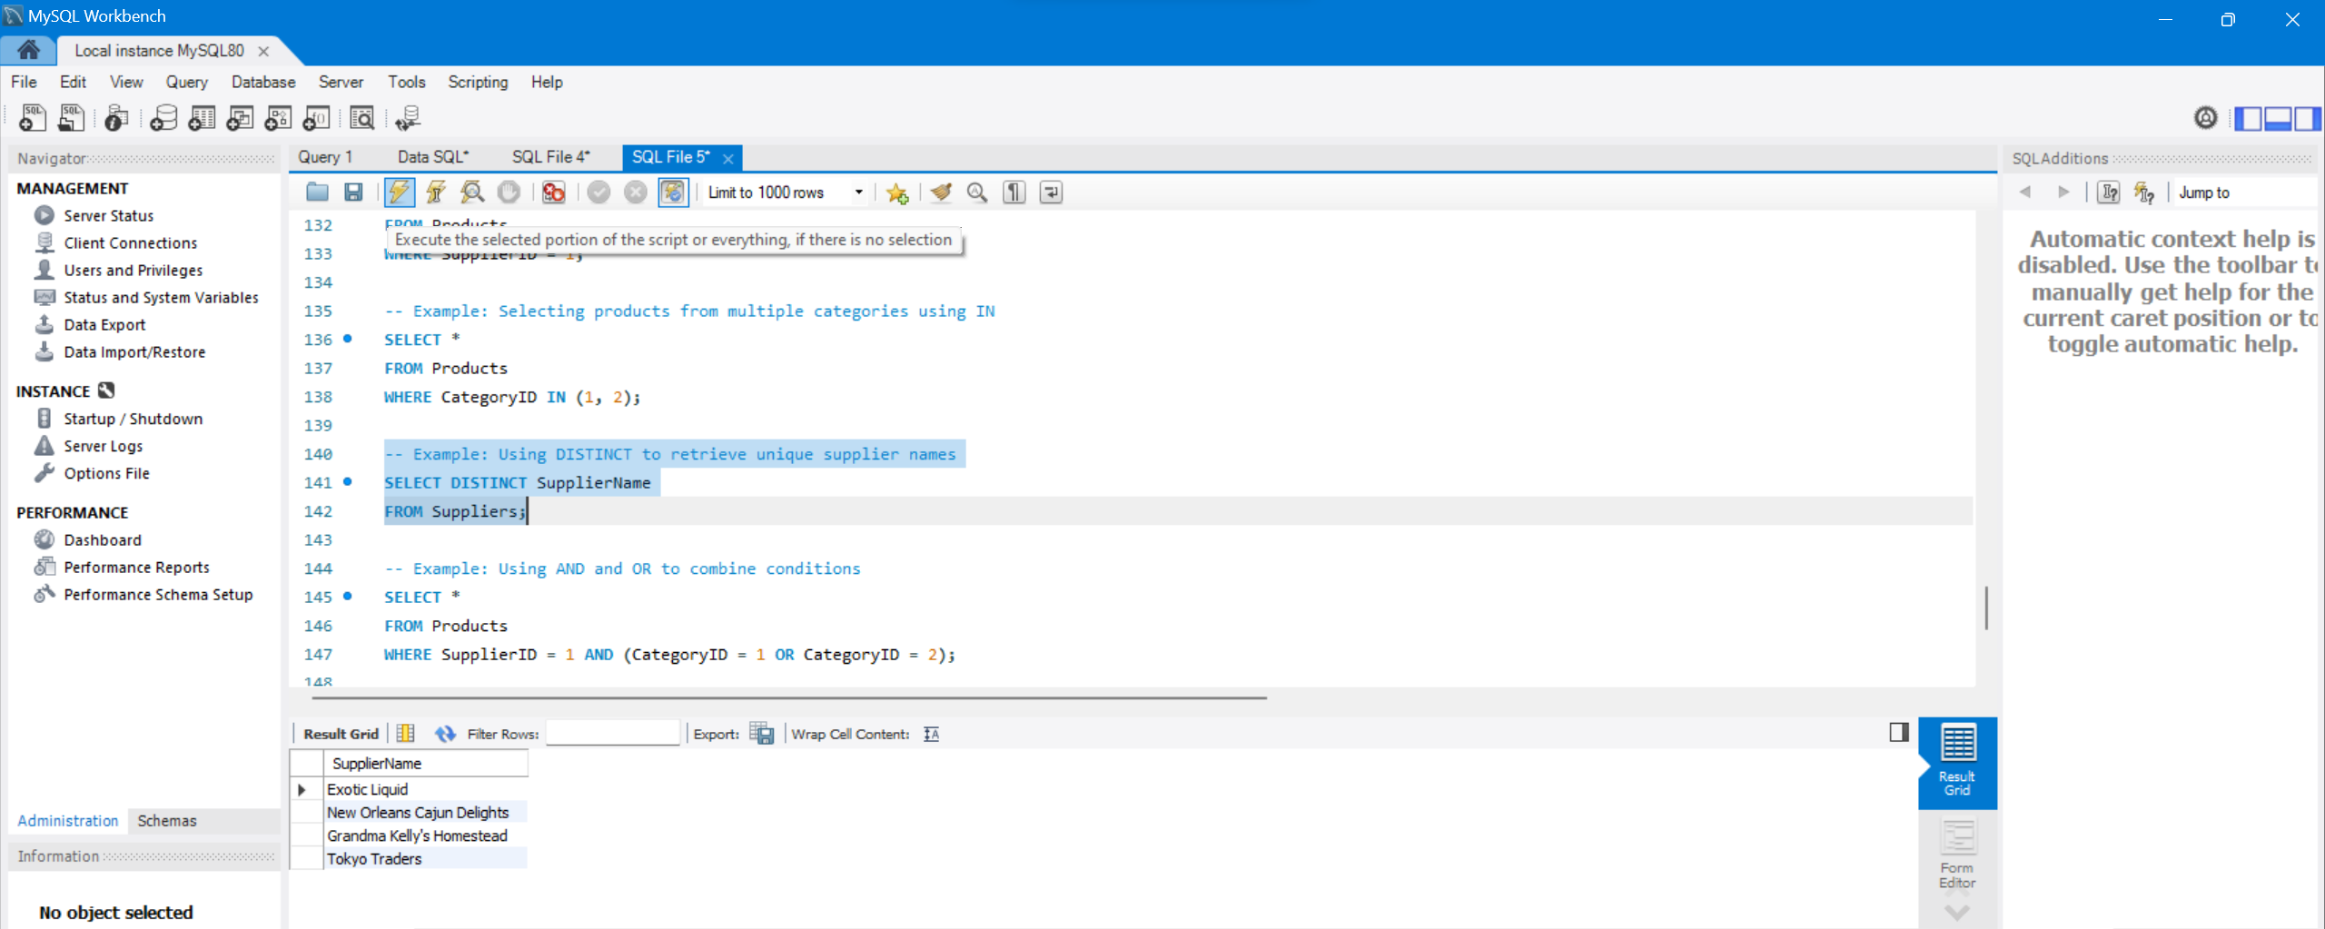

**AND , OR**

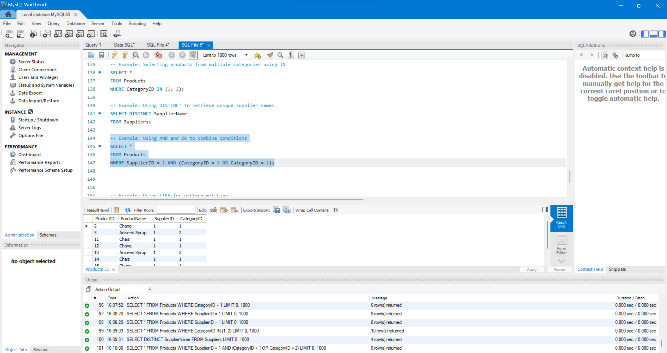

**LIKE**

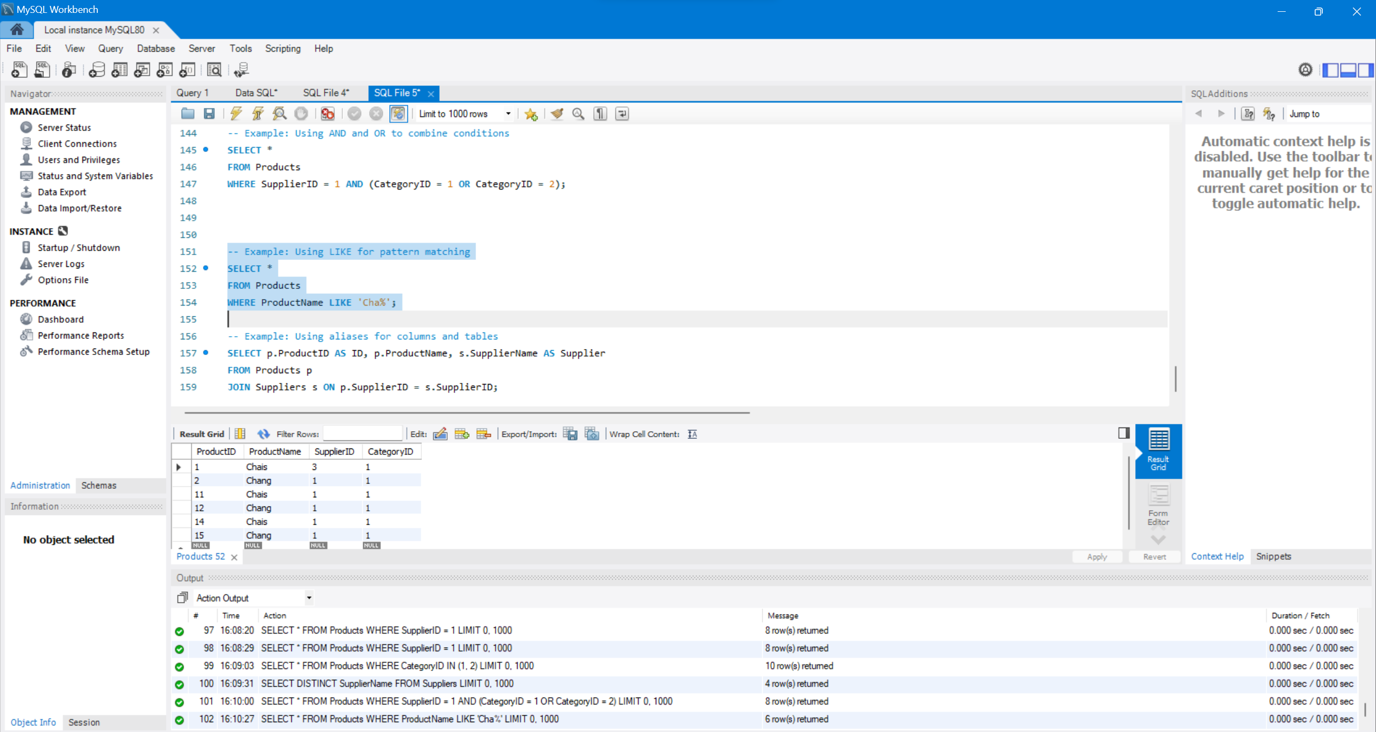

**ALIASES**

